Granhub Team – Day-to-Day Responsibilities

(Team Collaboration & Daily Working Pattern)

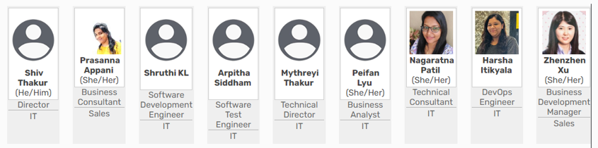

👩‍💼 Betsy Xu (Zhenzhen Xu) – Business Development Manager (Sales)
Main Focus: Partnerships, client relations, growth strategy
Daily Duties:
- Identify and engage potential partners (local councils, charities, healthcare providers, educational institutions).
- Draft and send outreach communications (emails, LinkedIn, follow-ups).
- Attend discovery calls and gather client requirements.
- Provide feedback to technical teams based on user and partner input.
- Support fundraising or sponsorship opportunities and marketing partnerships.
As the Business Development Manager, I work closely with both the Sales and IT teams to ensure smooth communication, problem-solving, and delivery of client-focused solutions. Below is a summary of my collaboration with each team member:

🧑‍💼 Shiv Thakur – Director (IT)
Main Focus: Project oversight and leadership
Daily Duties:
- Review overall project status and team delivery.
- Make key technical and business decisions.
- Approve final product features, releases, and priorities.
- Support strategy calls and high-level external communications.

👩‍💼 Prasanna Appani – Business Consultant (Sales)
Main Focus: Sales coordination and partner relationship management
Daily Duties:
- Assist Betsy in preparing partner proposals and presentation decks.
- Maintain CRM records for outreach efforts and follow-ups.
- Help schedule meetings and demos.
- Document key feedback from client sessions.

👩‍💻 Shruthi KL – Software Development Engineer (IT)
Main Focus: Platform development and coding
Daily Duties:
- Implement new features and fix bugs on Granhub.
- Collaborate with the QA team to ensure code quality.
- Participate in sprint planning and stand-up meetings.
- Coordinate technical feasibility checks with Peifan (BA).

🧪 Arpitha Siddham – Software Test Engineer (IT)
Main Focus: Testing and quality assurance
Daily Duties:
- Write and run test cases for all new features.
- Reproduce and report bugs found by users or partners.
- Ensure release readiness and issue test reports.
- Liaise with Shruthi to resolve defects.

🧑‍💻 Mythreyi Thakur – Technical Director (IT)
Main Focus: Technical architecture and performance
Daily Duties:
- Define system architecture and ensure platform scalability.
- Monitor system security, performance, and uptime.
- Provide mentoring and direction to the Dev and QA teams.
- Attend senior planning sessions with Shiv and Betsy.

📊 Peifan Lyu – Business Analyst (IT)
Main Focus: Requirements gathering and feature documentation
Daily Duties:
- Translate business goals into technical specifications.
- Work closely with Betsy and Prasanna to document user stories.
- Align with development team to ensure delivery matches expectations.
- Track KPIs and analytics tied to product success.

👩‍💻 Christine (Nagaratna Patil) – Technical Consultant (IT)
Main Focus: Client support and technical solutioning
Daily Duties:
- Join client demos with Betsy to offer technical insights.
- Assist in tailoring solutions for partners’ unique needs.
- Provide internal support for configuration and setup.
- Document best practices for platform use.

🛠️ Harsha Itikyala – DevOps Engineer (IT)
Main Focus: Deployment and platform maintenance
Daily Duties:
- Manage cloud infrastructure and CI/CD pipelines.
- Monitor system health and respond to incidents.
- Ensure new features are properly deployed and integrated.
- Coordinate closely with Shruthi and Arpitha for release management.

🌐 Cross-Team Collaboration
- Daily Standups: Brief team sync to review blockers, tasks, and priorities.
- Weekly Strategy Call: Led by Shiv and Betsy to align business goals with delivery.
- Shared Tools: Microsoft Planner (task tracking), Teams (communications), Confluence/GitHub (documentation), HubSpot (CRM)-pending proposed to develop.

Daily Coordination & Working Approach
- We use shared tools (e.g., Microsoft Teams, Microsoft Planner, GitHub) to maintain real-time communication and task tracking.
- We join the team’s daily standups at 10am everyday (or sync meetings twice a week) to report on client feedback and update the team on ongoing negotiations or opportunities.
- My role acts as the bridge between client needs and internal delivery, so I stay in daily contact with at least 3–4 team members depending on the task or project stage.
- We hold weekly project reviews to align on priorities, blockers, and upcoming client deadlines.

